Aleksas Murauskas

260718389

Q1.

Define the following

1. Adiabatic Process: A process in which no heat transfer occurs
2. Isothermal Process: A process in which the temperature of the system is constant
3. Thermal resistance: A property of a material that describes the material’s resistance to heat flow
4. Emissivity: The effectiveness the material has to emit energy through radiation

Answer the following:

1. The Zeroth Law of Thermodynamics is that if two bodies are in thermal equilibrium with a third body T, then the two bodies are in thermal equilibrium with each other. It is important as the definition of Temperature is necessary for the first and second laws of thermodynamics.
2. The first law of thermodynamics is the internal energy E_int of a system increases if energy is added as heat Q and tends to decrease if energy is lost as Work W is done by the system
3. Thermal Equilibrium occurs when two bodies have no heat flow between them, this occurs when they are both the same temperature. He will transfer from the body with higher temp to the lower body with lower temp until both are the same temp. A Thermodynamic Process is what occurs when the system transitions between states of equilibrium.
4. Heat Capacity C is The proportionality constant between the heat the object absorbs/releases and the resulting temperature change, shown in the equation . Specific Heat c is similar but rather than the whole object, it refers to the proportionality constant for the unit mass of the solid material, as shown in the equation . Specific Heat at constant volume and pressure are two different constants of an Ideal gas. Molar Specific heat at constant volume, C_v, can be defined as . Molar Specific Heat at constant pressure, C_P, can be found They share the relationship: The ratio of is vital in adiabatic processes as well.
5. The difference between a fridge and a heat pump is that a fridge works to move heat out of a low temperature reservoir into a high temperature room. A Heat pump works the opposite way, as it wants to add heat to the high temperature reservoir that is the room.
6. Free expansion is a special adiabatic process in which no heat is transferred with the environment and no work is done on or by the system, described by the equation . Constant-Volume refers to a process in which the volume of the system does not change and therefore no work was done on or by the system, so . A Cyclical Process is which after interchanges in heat and work, the system returns to it’s initial state so the change in internal energy is 0 so Q=W.
7. An ideal gas is one where the size of the molecules are insignificant compared to the volume of the container, all collisions are elastic and attractions and intermolecular forces are insignificant. The best conditions for this are a high temperature and low pressure.
8. When we measure Temp, can we determine?
   1. Internal Energy, For monatomic gases
   2. Pressure, No we need more than just Temperature, we also need volume
   3. Rms Speed yes
   4. A and C Yes, see above
   5. A, B, and C , no see above
9. Yes, Average translational kinetic energy of applies to all ideal gases

Q2.

Hot cup of Tea: T_Tea = 90 degree C

Stainless steel rod: diameter= 5mm, L=60mm, k= 43 W/m*C

Wooden Rod: diameter = 5mm, L, k= 0.17 W/m*C

Human hand: T_hand 33 degrees Celsius

1. What is the energy Transfer rate along the rod in each case, ignore convection.

Energy flow equation

For wooden rod:

For Steel Rod: Same area

1. How quickly would your skin heat up 5 degrees in each case?

Skin: Volume = 60 mm^3, Density = 1 mg/mm^3, Specific heat c = 3.47 J/g/DegreeC

Assume h = 10 W/m^2 K

To find Mass:

Time = Q/q

For Wood:

For Steel:

1. Assume the cup is well insulated. What is the heat flux from the surface due to convection

By Newton’s law of cooling:

1. What is the radiated heat flux from the surface of the cup?

Q3.

Silicon IC:

Silicone Elastomer:

Heat sink:

Heat Generation = 10 J/s,

1. Draw the thermal resistance network for the components, ignore convection for now. Find Thermal conductivities are 130 W/m*C for silicon, 0.5 W/m*C for elastomer and 202 W/m*C for aluminum heat sink.

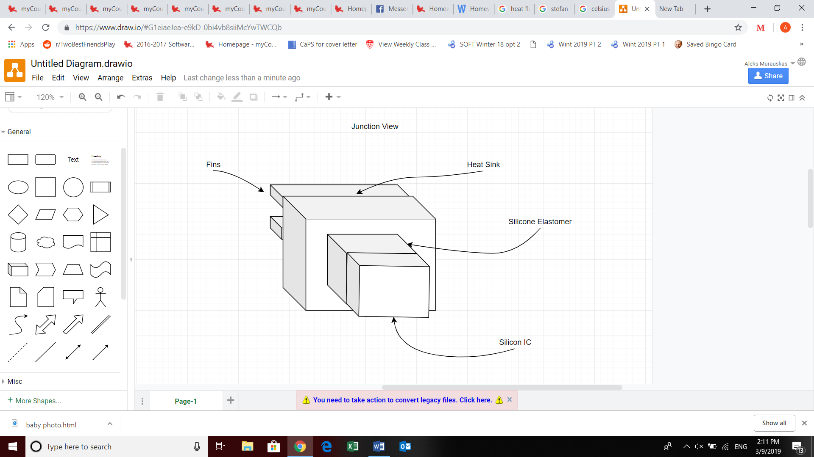

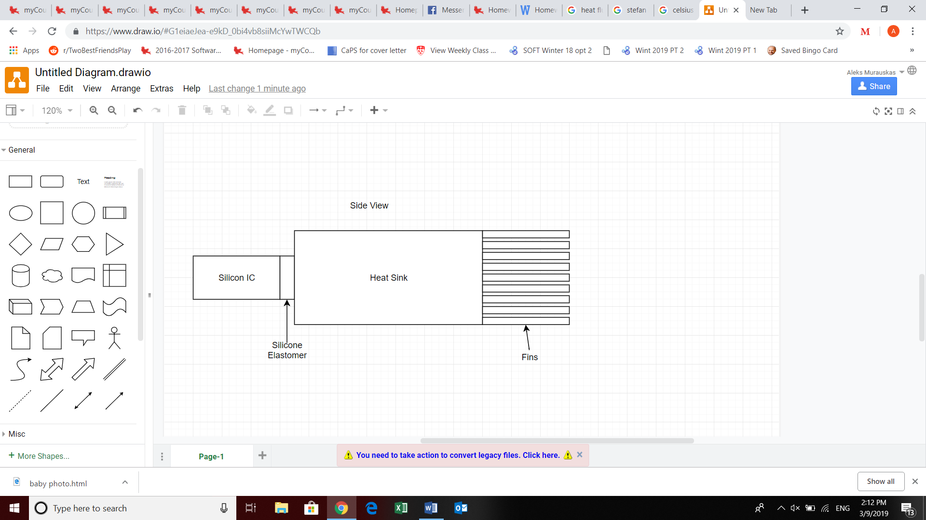

IC Resisance:

Elastomer:

Heat Sink: .01523

Heat drops over time: Heat drop = Thermal resistance * Heat generation

Starting temp = 85

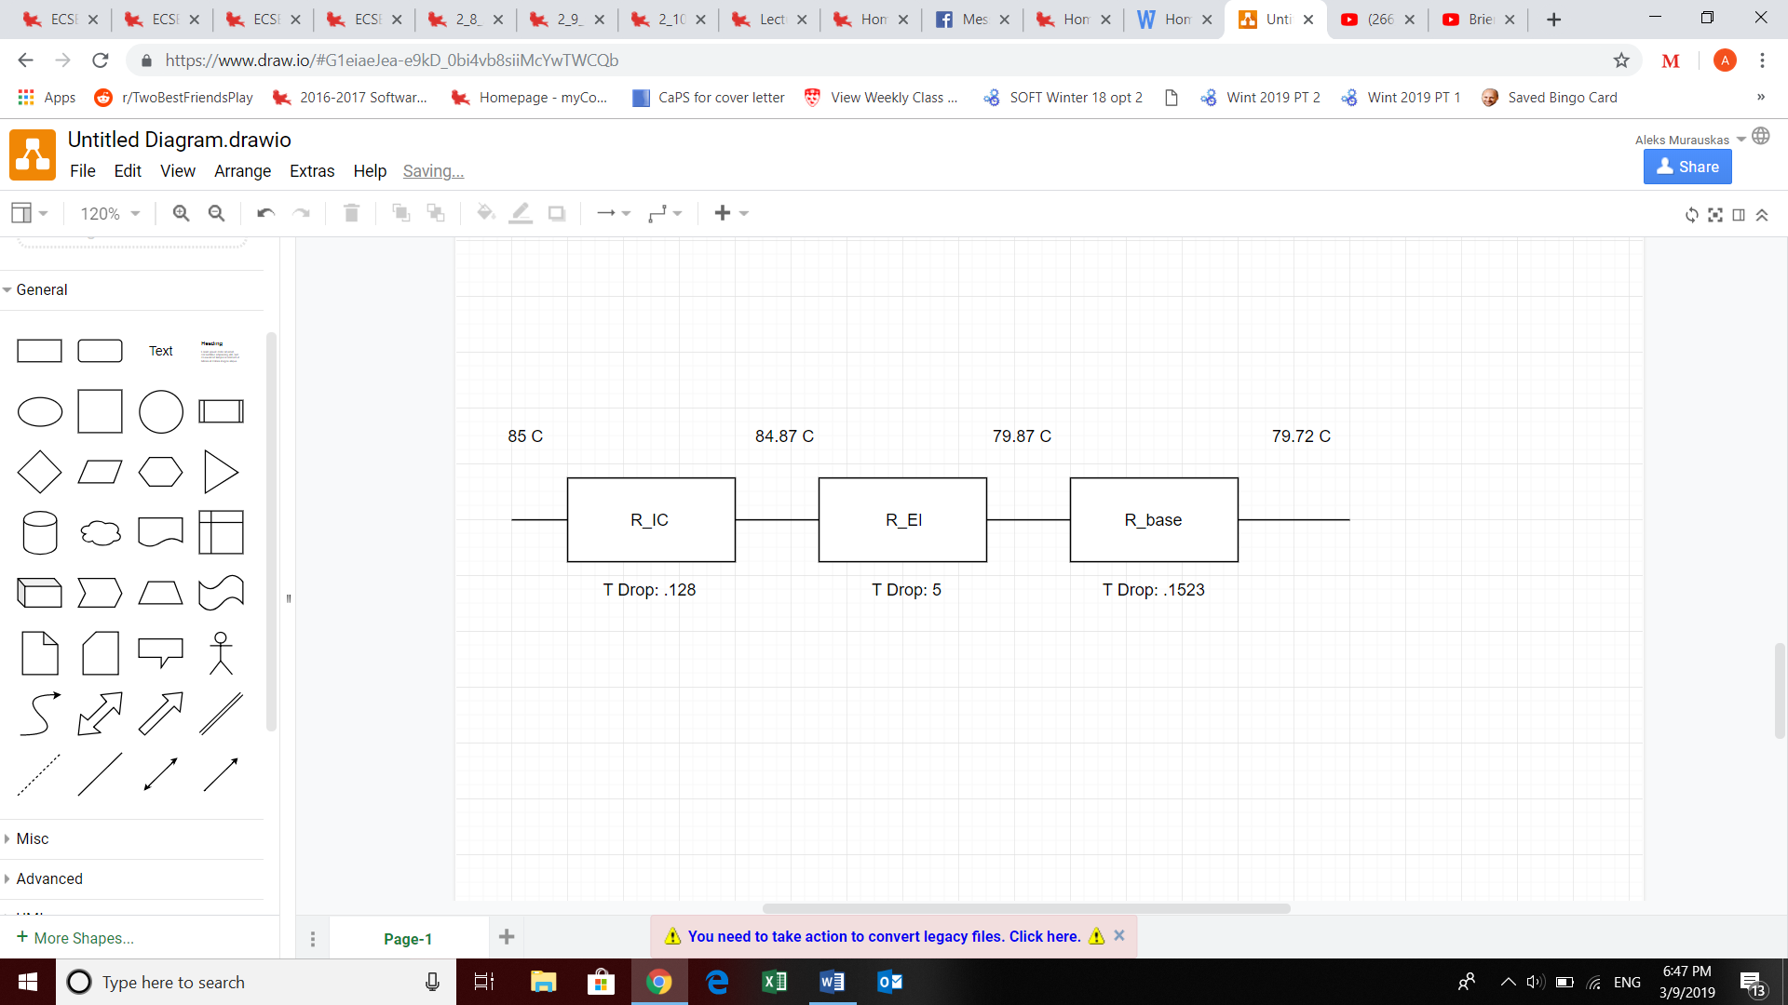

1. Assume the heat sink is cooled by convection. Does the heat sink require forced air convection.

Area of a fin:

Since h is less than 50 forced cooling is not necessary.

Q4.

Volume oscillates from 0.5 L to 1 L.

Pressure is 100 kPa in the compressed state

Fridge temp =0 C, room temp = 21 C

a

1. Complete the tables below, where the four points ABCD correspond to the Carnot Cycle in class

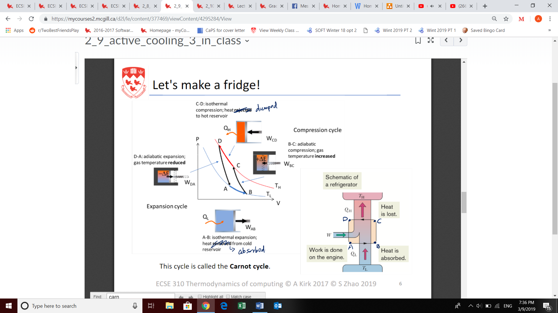

Order of solution:

Compression, or point D we know Temp= 21 C or 294.15, Volume is 0.5 and Pressure is 100 kPa.

T_L is given to be zero, therefore T_L= 273.15 K.

Using PV=nRT, nR = PV/T, and using D’s information , this remains constant.

Find pressure for B:

For D-A, It is an adiabatic

Now to find pressure at A

For B-C, It is an adiabatic

To find pressure at C

To start transitions, Begin with A-B

Because Q=W in Isothermal expansion, Q= 26.92

The change in entropy for isothermal processes is

Repeat for C-D:

Procceses B-C and D-A are adiabatic, therefor Q=0 and entropy change is 0

To find work

For B-C:

For D-A:

|  |  |  |  |  |  |  |  |
| --- | --- | --- | --- | --- | --- | --- | --- |
| Point | Volume(L) | Pressure (kPA) | Temp. K | Transition | Heat Flux (J) | Work (J) | Entropy change (J/K) |
| A | 0.56 | 82.91 | 273.15 | A-B | 26.92 | 26.92 | 0.099 |
| B | 1 | 46.43 | 273.15 | B-C | 0 | -5.4 | 0 |
| C | 0.894 | 55.9 | 294.15 | C-D | -29.05 | -29.05 | -0.099 |
| D | 0.5 | 100 | 294.15 | D-A | 0 | 5.4 | 0 |

1. Assume you need to cool 250 mL of water from 21 C to 0 C by putting it inside the fridge.
2. How many cycles will it take?

Heat capacity of water is 4.18 and the ratio of mL to grams of water is one to one.

For each cycle, A-B takes 26.92 heat away from the cold reservoir.

1. By how much does the entropy of the water change on the first cycle?
2. By how much does the entropy of the water change in total?
3. If you find that entropy has reduced, Where has it gone?

The entropy has reduced, and has travelled from the water into the hot reservoir also known as the room.

1. Find efficiency